## **Before changing the background:**

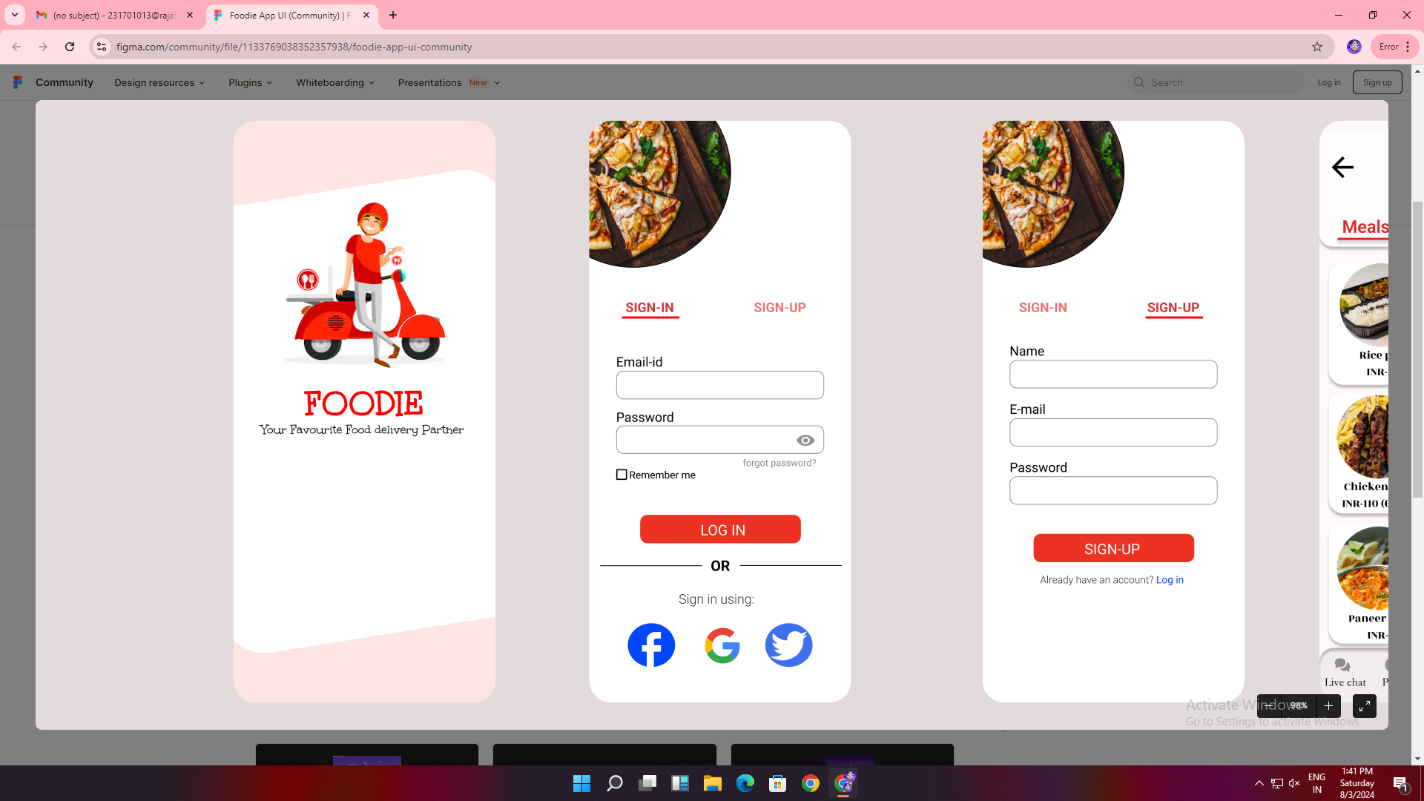

**AIM**: Develop a design of a mobile (or) web application to change background and menu

**PROCEDURE**:

1. Open Figma and create a new file

2. Set up frames of different screen sizes

3. Gather Resources

4. Start with outline to a low defined basic structure

5. Include all essential components like logo search bar etc

6. Refine the design ensuring all the elements are pixel perfect

7. Change the Background and menu

8. Export the design assets for development

## **After changing the background:**

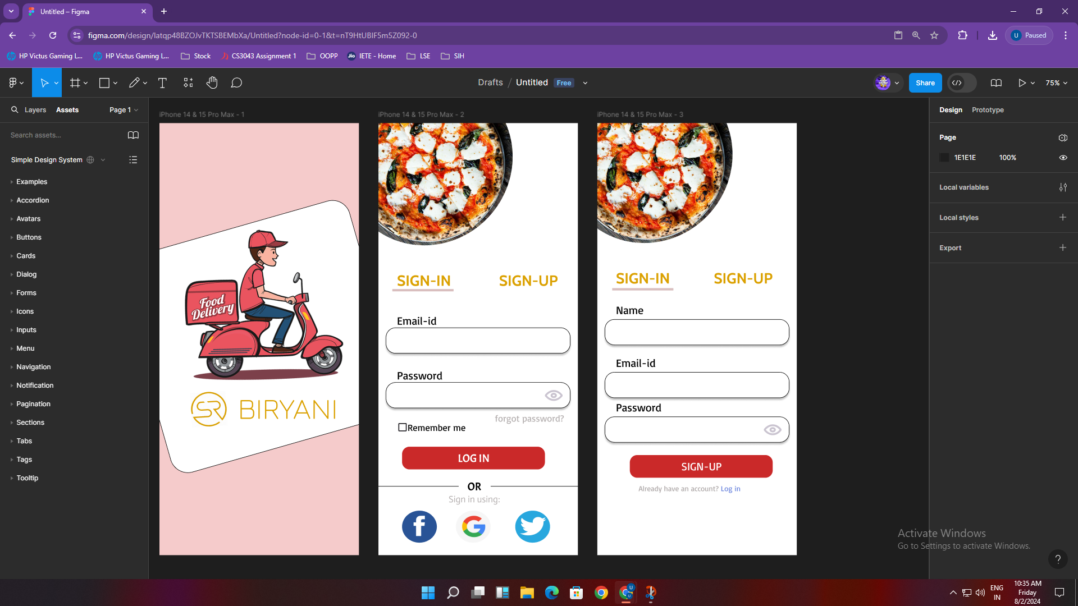

**Result**: The experiment is done and output is verified